DBMS

Ex–3 Select Commands

Name:- K. DUSHYANT REDDY Reg No.:- RA1911033010029

Branch:- CSE-SE

AIM:

To implement Select commands to perform conditions where, and, or, like, order by, group by, having.

COMMANDS:

1. WHERE – Used to filter certain records in tables.

Syntax-

SELECT <column name> from <table-name> WHERE condition;

CODE-

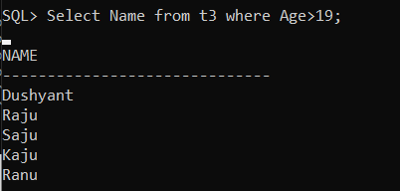

1. AND – Used to specify multiple conditions in the table.

Syntax-

SELECT <column name> from <table-name> WHERE condition1 AND condition2;

CODE-

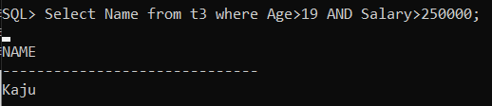

1. OR – Used to specify one of the multiple conditions in the table.

Syntax-

SELECT <column name> from <table-name> WHERE condition1 OR condition2;

CODE-

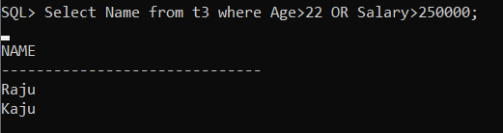

1. LIKE – Used to find patterns in the table.

Syntax-

SELECT <column name> from <table-name> WHERE <column name> LIKE condition;

CODE-

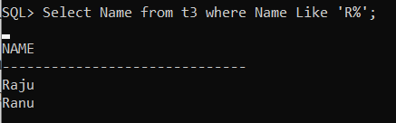

1. ORDER BY – Used to arrange the records in the table.

Syntax-

SELECT <column name> from <table-name> ORDER BY condition ASC|DESC;

CODE-

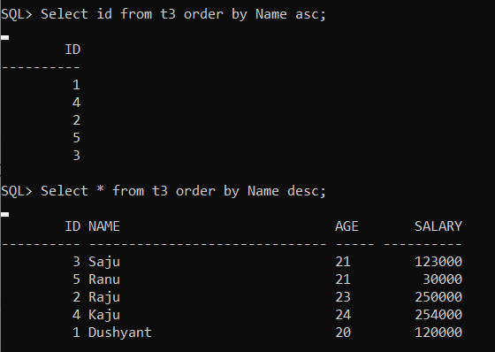

1. HAVING – Used with aggregate functions in the table.

Syntax-

SELECT <column name> aggregate function<column name> from <table-name> GROUP BY <column name> HAVING condition;

CODE-

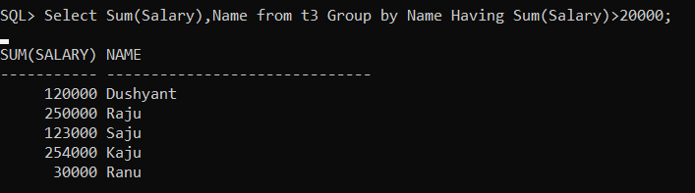

1. GROUP BY – Used to group rows that have same value in the table.

Syntax-

SELECT <column name> from <table-name> GROUP BY <column name>;

CODE-

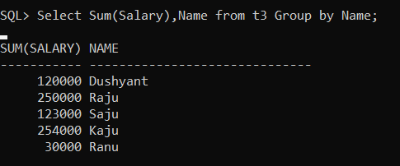

1. DISTINCT – Used to retrieve only unique data in the table.

Syntax-

SELECT DISTINCT <column name> from <table-name>;

CODE-

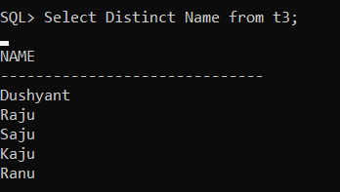

RESULT:

Thus, the Select commands have been executed successfully